**Detecting Parkinson’s Disease Using IBM Watson**

**Machine Learning**

1.INTRODUCTION:

* 1. Overview:

Parkinson's disease is a progressive nervous system disorder that affects movement. Symptoms start gradually, sometimes starting with a barely noticeable tremor in just one hand. Tremors are common, but the disorder also commonly causes stiffness or slowing of movement. Although Parkinson's disease can't be cured, medications might significantly improve your symptoms.

It is estimated that 60,000 new cases of Parkinson’s

disease are diagnosed each year. There is no x-ray or blood test that

can confirm the disease. The researchers found that the drawing

speed was slower and the pen pressure is lower among Parkinson’s

patients. One of the indications of Parkinson’s is tremors and rigidity

in the muscles, making it difficult to draw smooth spirals and waves. It

is possible to detect Parkinson’s disease using the drawings alone

instead of measuring the speed and pressure of the pen on paper.

Our project goal is to quantify the visual

Appearance (using HOG method) of these drawings and then train a

machine learning model to classify them. In this project, we are using,

Histogram Of Oriented Gradients (HOG) image descriptor along with a

Random Forest Classifier to automatically detect Parkinson’s disease in

Hand-drawn images of spirals and waves.

1.2 Purpose:

More than 10 million people are living with Parkinson’s Disease worldwide, according to the Parkinson’s Foundation. The researchers found that the drawing speed was slower and the pen pressure is lower among Parkinson’s patients. So, App-based detection can be handy for many users for self diagnosing instead of going to hospital for detection.

2 LITERATURE SURVEY

            2.1 Existing problem:

Even though technology is developing fastly , there is no proper way to detect parkinson’s disease .People have to go to the doctor for detection of the disease. As we know that there is no proper test to recognize the problem and the symptoms may get worse in the mean time. So, an app based detection may helpful for the person for diagnosing themselves whether they are effected with parkinson’s disease or not.

   2.2 proposed solution:

An app based application which accurately detects the presence of Parkinson’s disease in an individual by taking the hand-drawn images of spirals and waves drawn by them as input is helpful for detecting parkinson’s disease before it becomes worse.This will be helpful for a person to start medication in the proper time.

3 THEORITICAL ANALYSIS:

            3.1 Block diagram:

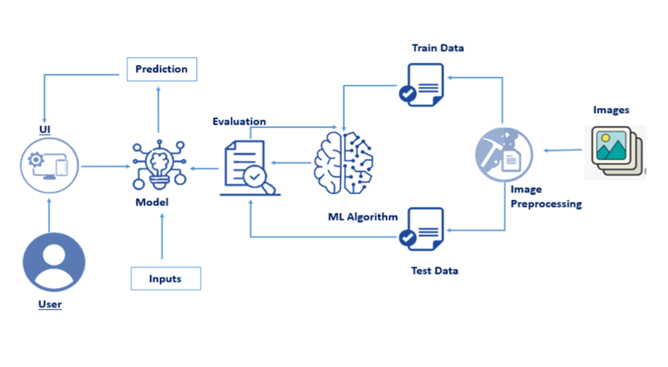

User will give the input to the UI. The inputs given to the UI will be evaluated by the training given to the ML algorithm. Given images are classified into healthy or Parkinson's based on the training given to the algorithm and the output is predicted accordingly.

3.2 Hardware / Software designing:

            We first Train the model in the available python IDE(better to use spyder or pycharm) and then integrate it with Flask in IBM

In training the model the important steps are :

1.Split the data into train and test.

2.Importing the necessary libraries required for image preprocessing

3. And then we have to load the dataset for training the model.

4.Train the model using Random Forest classifier as it gives more accuracy for our model.

5.Test the model and save it as pickle (.pkl) file

TEST RESULT:-

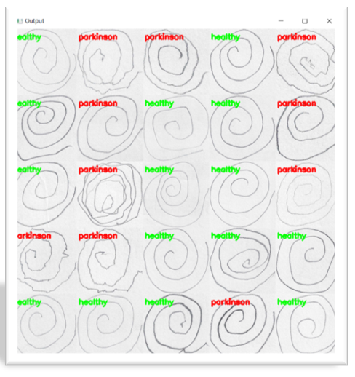

**Application Building:**

* Build the html pages for the web pages
* Build the css for styling
* Build the python code and connect the HTML and CSS files to the python code.
* Save the python code
* Run the python code

**Running the Python code:**

* Open the anaconda prompt
* Navigate to the folder where your python code is saved
* Now type python file_name.py
* Python code will run in the port given in the code if there are no errors
* Now in the browser type localhost:port_number given in the code
* The web application for your trained model will open
* Now predict the output by giving new patient’s hand-drawn images

**IBM Deployment:**

 1.As we have saved the model in the folder, now we have to deploy it in the IBM for getting an URL for our application to make it available for the end user.

2.For that login into the IBM account and create an app in the Python flask app.

3.Now connect to the IBM Watson using cf login in the prompt and push your app to IBM Watson using the command cf push "app_name".

4.If the app is successfully pushed then it starts running and a URL is generated for the app.

4 EXPERIMENTAL INVESTIGATIONS:

As our model’s accuracy is not 100% some results may be wrongly predicted. So, we have to analyse the model for its better accuracy.

We have to analyse the inputs given and the trained images and make required changes for better accuracy of the app.

 5 FLOWCHART:

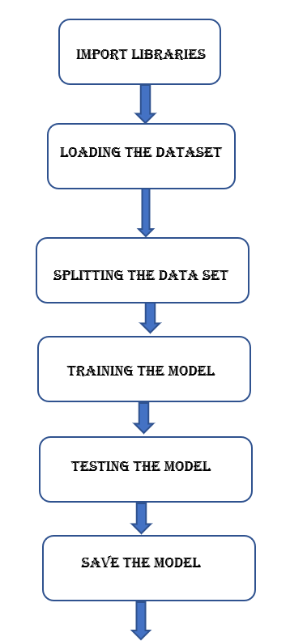

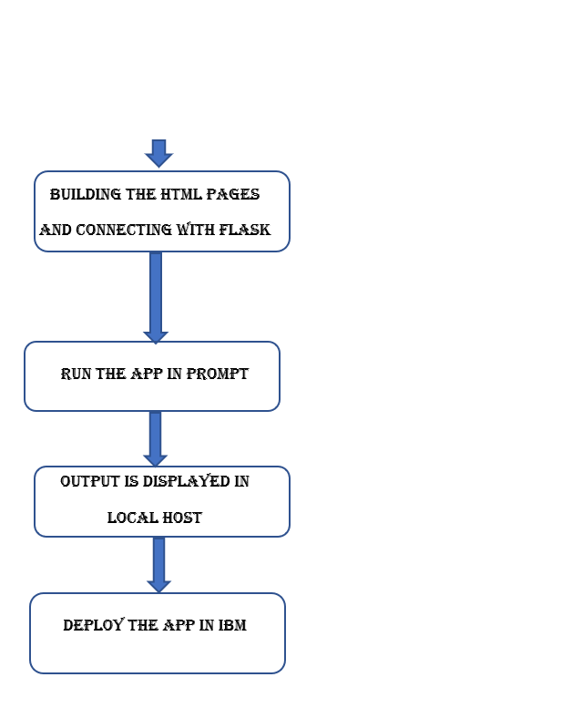

    6 RESULT:

**Home page:**

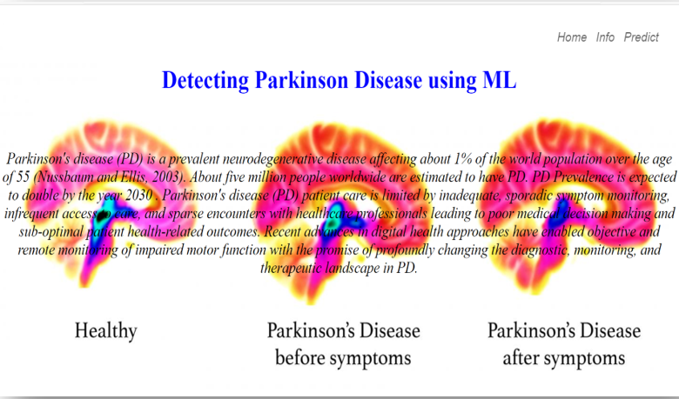

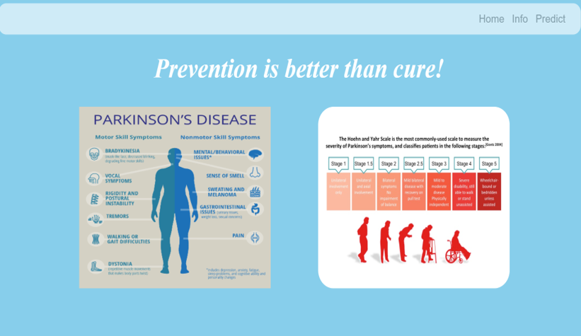

**The above image is info page**

**Predict page:**

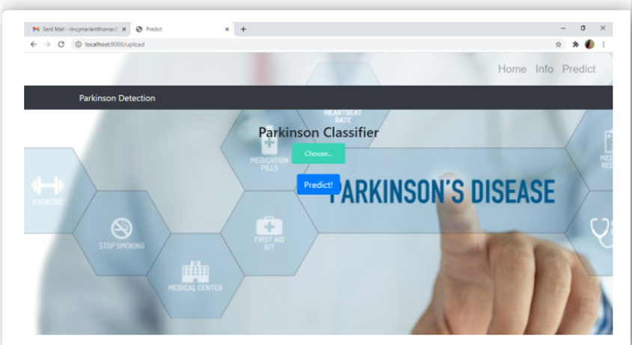

**Result:**

here we will upload the images and find out whether the person is effected be Parkinson's disese or not

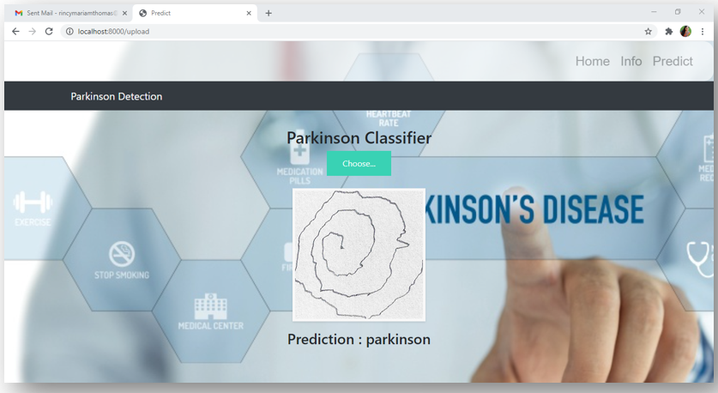

     7 ADVANTAGES & DISADVANTAGES:

         7.1 ADVANTAGES:

1.User can easily understand the UI and diagnose themselves quickly by uploading their hand-drawn images

2.Need not go to the doctor for detecting the disease

3.If the patient has any doubt he can easily clarify by using this app and reach out to doctor if he is diagnosed with the disease.

4.Finally, we may reduce death rate caused by the parkinson’s disease.

                         7.2  DISADVANTAGES:

As the accuracy is not 100% we may have some wrong results when the images matches both the features of healthy and parkinson’s effected person.

8.APPLICATIONS:

It is applicable in medical field for early detection of parkinson’s disease.

It is helpful for the treatment of the disease

 9.CONCLUSION :

We have build the App based application that detects the parkinson’s disease

This may helpful for the early detection by the user itself without doctor’s help and can approach the doctor for the treatment.

10.FUTURE SCOPE:

1.This app is helpful for researchers in knowing more about the parkinson’s disease.

2.If we improvise this model then this may helpful in treatment too.

3.As we are busy in our day to day activities , this app helps you to recognize the problem.

4. This may help the  doctors for the identification and treatment of the parkinson’s disease effected person.

11.BIBILOGRAPHY:

      Dataset and code reference given by --  <https://smartinternz.com/>

IBM Cloud -- <https://cloud.ibm.com/login>

HTML background images – <https://www.google.com/>

    Theory reference – <https://www.google.com/>